# **Name: Abdurrahman Qureshi**

# **Roll No: 242466**

Practical No: 8

Date Of Performance: 18/09/2025

Aim: Implementation of React Functional Components and prop using Vite.

Q) Create functional components to render h1 and p tags

CODE (Quote):

export default function Hero() {

    return (

        <div className="h-screen w-screen flex justify-center items-center flex-col">

            <h1 className="text-5xl">"Revenge is fool's game"</h1>

            <p className="text-3xl">

                - Arthur Morgan

            </p>

        </div>

    );

}

CODE (Rendering):

import Hero from "./components/Hero";

export default function Home() {

  return (

    <>

      <Hero />

    </>

  );

}

OUTPUT:

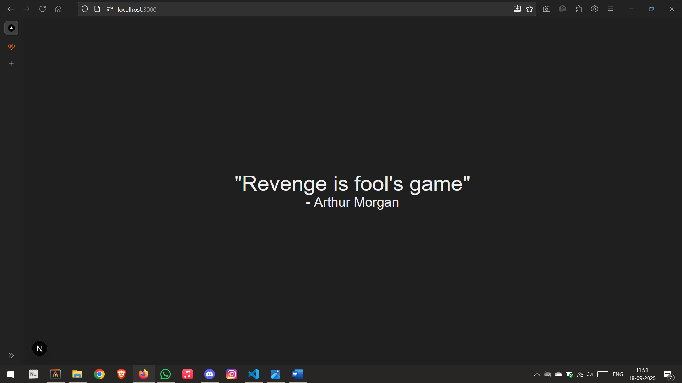

Q) Create at least three functions with h1,p,li and image and render them

CODE (Gang):

"use client";

import Image from "next/image";

import IMG from "../../public/img/Red Dead Redemption Dutch.jpg";

export default function Gang() {

    const gangMembers = [

        { name: "Dutch van der Linde", role: "Gang leader" },

        { name: "Arthur Morgan", role: "Senior enforcer and lead debt collector" },

        { name: "John Marston", role: "Gunslinger and former delinquent" },

        { name: "Hosea Matthews", role: "Master con artist and co-founder" },

        { name: "Susan Grimshaw", role: "Camp overseer and disciplinarian" },

        { name: "Micah Bell", role: "Gunslinger and recent recruit" },

        { name: "Bill Williamson", role: "Enforcer and former soldier" },

        { name: "Javier Escuella", role: "Expert tracker and revolutionary" },

        { name: "Charles Smith", role: "Hunter and skilled warrior" },

        { name: "Lenny Summers", role: "Young protégé and intelligent operator" },

        { name: "Sean MacGuire", role: "Irish gunslinger" },

        { name: "Karen Jones", role: "Con artist and drinker" },

        { name: "Mary-Beth Gaskill", role: "Bookworm and pickpocket" },

        { name: "Tilly Jackson", role: "Former street gang member" },

        { name: "Leopold Strauss", role: "Loan shark and financier" },

        { name: "Josiah Trelawny", role: "Mysterious con artist" },

        { name: "Reverend Swanson", role: "Opium-addicted preacher" },

        { name: "Uncle", role: "Old hanger-on and self-proclaimed cancer survivor" },

        { name: "Molly O'Shea", role: "Dutch's romantic interest" },

        { name: "Abigail Roberts", role: "John Marston's love interest" },

        { name: "Jack Marston", role: "Abigail and John's young son" },

        { name: "Sadie Adler", role: "Recent widow turned fierce fighter" },

        { name: "Kieran Duffy", role: "Former O'Driscoll turned loyal member" },

        { name: "Simon Pearson", role: "Camp cook and butcher" }

    ];

    return (

        <div className="relative h-screen w-screen overflow-hidden">

            <Image

                src={IMG}

                alt="Red Dead Redemption 2"

                className="w-full h-full object-cover absolute top-0 left-0 z-10"

                width={1920}

                height={1080}

                priority

            />

            <div className="relative z-20 h-full w-full flex flex-col items-center justify-center bg-opacity-60 p-4">

                <h1 className="text-5xl md:text-6xl font-bold text-amber-400 mb-2 font-rye drop-shadow-lg">

                    Van der Linde Gang

                </h1>

                <p className="text-2xl md:text-3xl text-amber-200 mb-6 font-special">

                    Members

                </p>

                <div className="grid grid-cols-1 sm:grid-cols-2 md:grid-cols-3 lg:grid-cols-4 gap-4 w-full max-w-6xl px-4 overflow-y-auto py-4">

                    {gangMembers.map((member, index) => (

                        <div

                            key={index}

                            className="backdrop-blur-2xl bg-opacity-70 rounded-lg p-3 border transition-colors"

                        >

                            <h3 className="text-xl font-bold text-amber-300">{member.name}</h3>

                            <p className="text-amber-100 text-sm mt-1">{member.role}</p>

                        </div>

                    ))}

                </div>

            </div>

        </div>

    );

}

CODE (Rendering):

import Gang from "./components/Gang";

export default function Home() {

  return (

    <>

      <Gang />

    </>

  );

}

OUTPUT:

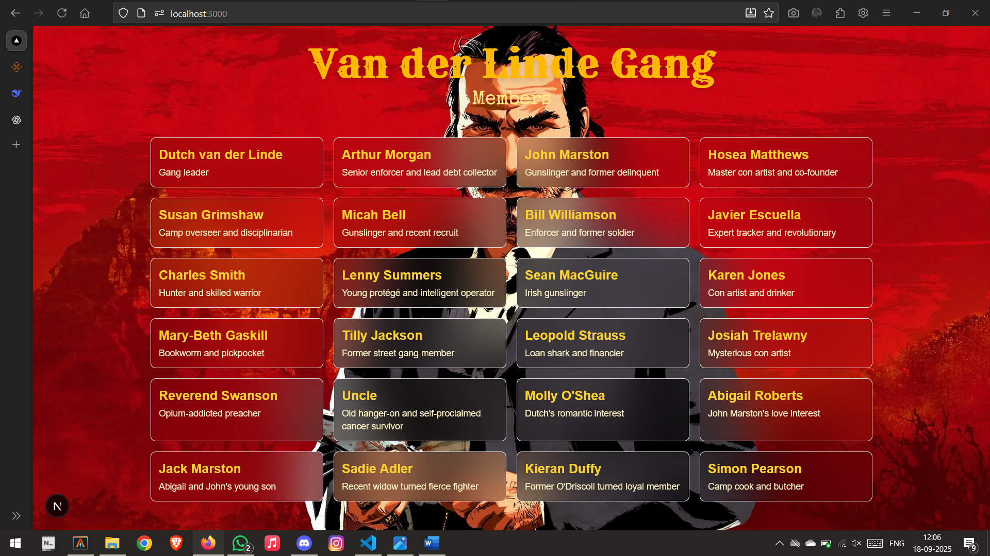

Q) Create a functional component with props

CODE (Animals):

"use client";

import Image from "next/image";

import IMG from "../../public/img/Red Dead Redemption Arthur (9).jpg";

interface Animal {

    name: string;

    location: string;

    species: string;

    desc: string;

}

export default function LegendaryAnimals({ animals }: { animals: Animal[] }) {

    return (

        <div className="relative h-screen w-screen overflow-hidden">

            <Image

                src={IMG}

                alt="Red Dead Redemption 2"

                className="w-full h-full object-cover absolute top-0 left-0 z-10"

                width={1920}

                height={1080}

                priority

            />

            <div className="relative z-20 h-full w-full flex flex-col items-center justify-center bg-opacity-60 p-4">

                <h1 className="text-5xl md:text-6xl font-bold text-amber-900 mb-2 font-rye drop-shadow-lg">

                    Legendary Animals

                </h1>

                <div className="grid grid-cols-1 sm:grid-cols-2 md:grid-cols-3 lg:grid-cols-4 gap-4 w-full max-w-6xl px-4 py-4">

                    {animals.map((animal, index) => (

                        <div

                            key={index}

                            className="backdrop-blur-2xl bg-opacity-70 rounded-lg p-3 border transition-colors"

                        >

                            <h3 className="text-xl font-bold text-amber-900">{animal.name}</h3>

                            <p className="text-amber-900 text-sm mt-1">

                                <span className="font-semibold">Location:</span> {animal.location}

                            </p>

                            <p className="text-amber-900 text-sm">

                                <span className="font-semibold">Species:</span> {animal.species}

                            </p>

                            <p className="text-amber-900 text-xs mt-2">{animal.desc}</p>

                        </div>

                    ))}

                </div>

            </div>

        </div>

    );

}

CODE (Rendering):

import Animals from "@/app/components/Animals";

export default function Home() {

  return (

    <>

      <Animals animals={animals} />

    </>

  );

}

const animals = [

  {    name: "Legendary Bear",

    location: "Grizzlies East, north of O'Creagh's Run",

    species: "Grizzly Bear",

    desc: "A massive, scarred bear with unmatched strength and aggression."

  },

  {    name: "Legendary Beaver",

    location: "Elysian Pool, north of Van Horn",

    species: "Beaver",

    desc: "A rare beaver with dark fur, skilled at evading predators."

  },

  {    name: "Legendary Boar",

    location: "Bluewater Marsh, northeast of Lagras",

    species: "Boar",

    desc: "An unusually large boar with white fur, extremely aggressive."

  },

  {    name: "Legendary Buck",

    location: "West Elizabeth, near Big Valley",

    species: "Buck",

    desc: "A majestic buck with a white coat, agile and swift."

  },

  {    name: "Legendary Cougar",

    location: "Gaptooth Ridge, west of Tumbleweed",

    species: "Cougar",

    desc: "Known as the Ghost Cat, stealthy and deadly."

  },

  {    name: "Legendary Coyote",

    location: "Scarlett Meadows, southeast of Rhodes",

    species: "Coyote",

    desc: "A cunning coyote with a distinctive pale coat."

  },

  {    name: "Legendary Elk",

    location: "Cumberland Forest, east of Bacchus Station",

    species: "Elk",

    desc: "A giant elk with huge antlers and white fur markings."

  },

  {    name: "Legendary Fox",

    location: "Mattock Pond, north of Rhodes",

    species: "Fox",

    desc: "A rare fox with silver fur, quick and elusive."

  },

  {    name: "Legendary Moose",

    location: "Roanoke Ridge, northeast of Annesburg",

    species: "Moose",

    desc: "A massive moose with sprawling antlers and pale fur."

  },

  {    name: "Legendary Panther",

    location: "Bolger Glade, southeast of Rhodes",

    species: "Panther",

    desc: "A deadly predator, swift and stealthy, with dark fur."

  },

  {    name: "Legendary Pronghorn",

    location: "Rio Del Lobo Rock, New Austin",

    species: "Pronghorn",

    desc: "A swift pronghorn with white fur and long horns."

  },

  {    name: "Legendary Ram",

    location: "Cattail Pond, northwest of Valentine",

    species: "Ram",

    desc: "A massive ram with curled horns and a unique coat."

  },

  {    name: "Legendary White Bison",

    location: "Lake Isabella, Grizzlies West",

    species: "Bison",

    desc: "A sacred beast with pure white fur, strong and resilient."

  },

  {    name: "Legendary Wolf",

    location: "Cotorra Springs, north of Fort Wallace",

    species: "Wolf",

    desc: "A large wolf with black-and-white fur, highly aggressive."

  }

];

OUTPUT:

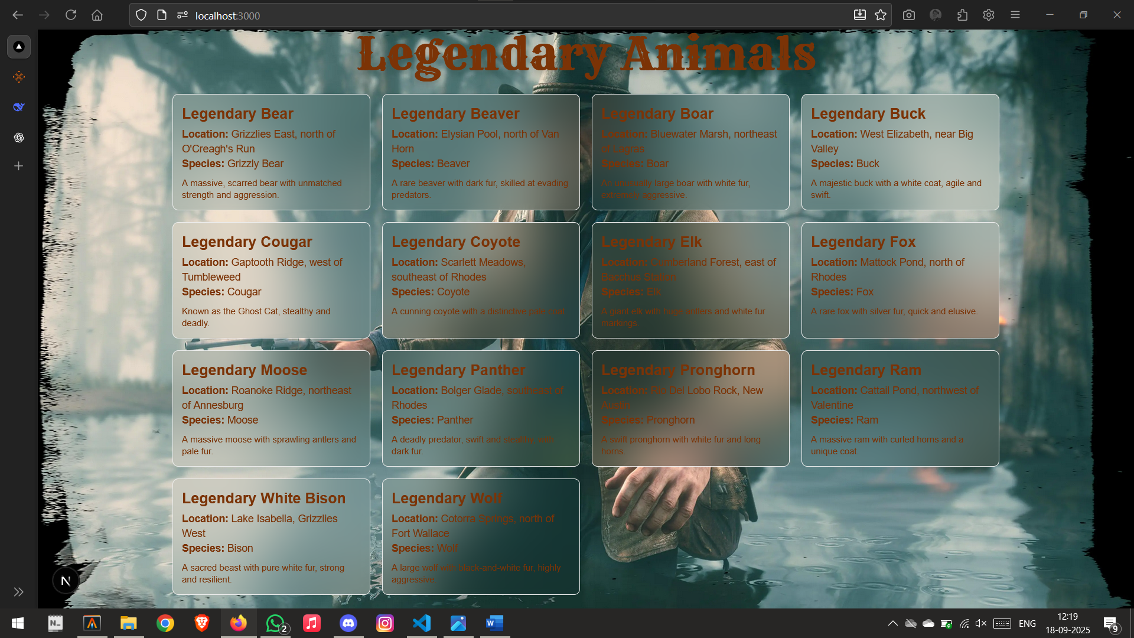

Q) Create functional component to render a profile page

CODE (John):

"use client";

import Image from "next/image";

import JohnIMG from "../../public/img/Red Dead Redemption John (2).jpg";

export default function John() {

    const profile = {

        name: "John Marston",

        fullName: "John Marston",

        born: "1873",

        died: "1911 (Beecher’s Hope, West Elizabeth)",

        family: "Husband to Abigail Roberts, father to Jack Marston",

        role: "Former Van der Linde Gang gunslinger",

        desc: "John Marston was once an outlaw in the Van der Linde gang, known for his gunslinging skills and troubled past. After the gang’s collapse, he sought redemption by building a life with Abigail and their son, Jack. Despite his efforts to live peacefully, John was forced into violence once again by the Bureau of Investigation, ultimately leading to his tragic death.",

    };

    return (

        <div className="relative min-h-screen w-full bg-gradient-to-b from-stone-900 via-stone-800 to-stone-900 text-amber-100">

            <div className="relative h-64 w-full">

                <div className="absolute inset-0 flex items-center justify-center">

                    <h1 className="text-4xl md:text-6xl font-bold text-amber-400 drop-shadow-lg font-rye">

                        John Marston

                    </h1>

                </div>

            </div>

            <div className="max-w-4xl mx-auto mt-[-4rem] relative z-10 p-6">

                <div className="bg-stone-800/80 backdrop-blur-lg rounded-2xl shadow-xl p-6 flex flex-col md:flex-row items-center gap-6 border border-stone-700">

                    <div className="w-44 h-44 relative flex-shrink-0 rounded-xl overflow-hidden border-2 border-amber-400 shadow-md">

                        <Image

                            src={JohnIMG}

                            alt={profile.name}

                            fill

                            className="object-cover"

                        />

                    </div>

                    <div className="flex flex-col">

                        <h2 className="text-2xl md:text-3xl font-bold text-amber-300">

                            {profile.fullName}

                        </h2>

                        <p className="text-sm italic text-amber-200 mb-2">{profile.role}</p>

                        <ul className="space-y-1 text-sm">

                            <li>

                                <span className="font-semibold">Born:</span> {profile.born}

                            </li>

                            <li>

                                <span className="font-semibold">Died:</span> {profile.died}

                            </li>

                            <li>

                                <span className="font-semibold">Family:</span> {profile.family}

                            </li>

                        </ul>

                        <p className="mt-4 text-sm leading-relaxed text-amber-100">

                            {profile.desc}

                        </p>

                    </div>

                </div>

            </div>

        </div>

    );

}

CODE (Rendering):

import John from "@/app/components/John";

export default function Home() {

  return (

      <John />

  );

}

OUTPUT:

